ASSIGNMENT 11
1.
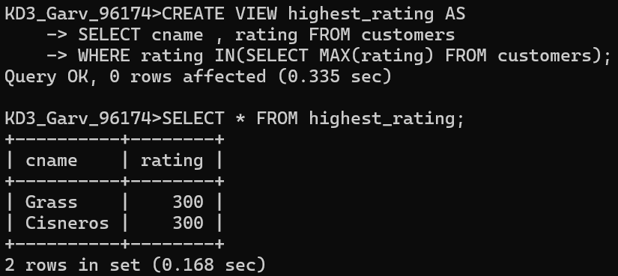
2.
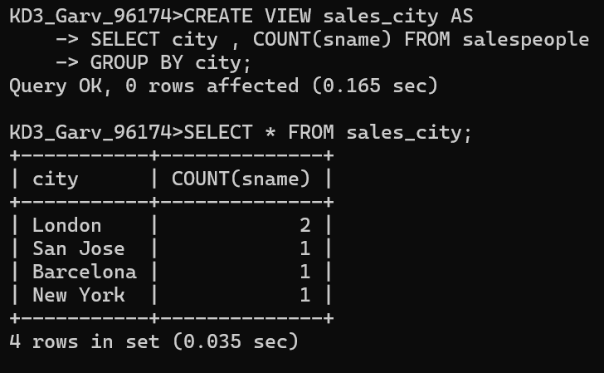
3.
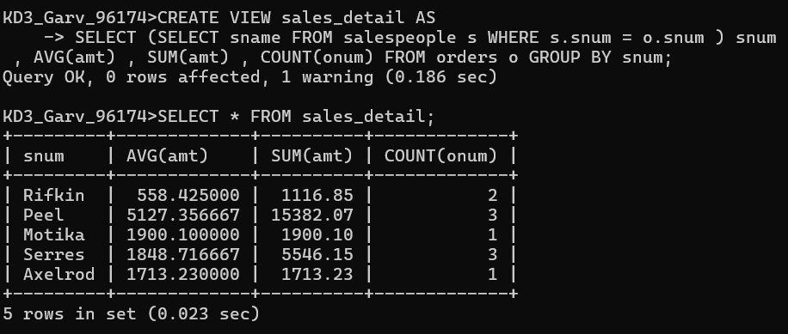

4.
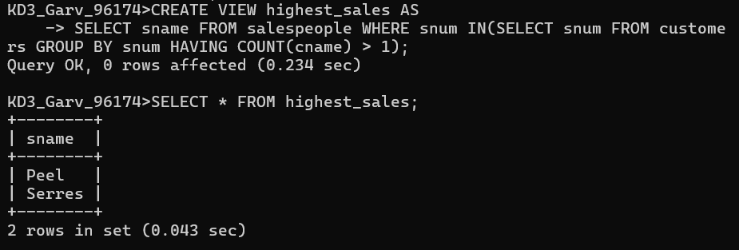
5.
WE can not perform DML operation on :
#1 MySQL does not allow DML on views with DISTINCT
#2 Uses SUM() (aggregate function)
these makes it non-updateable.
#3 Since Dailyorders is NOT updateable (because of DISTINCT),
this view also becomes NOT updateable

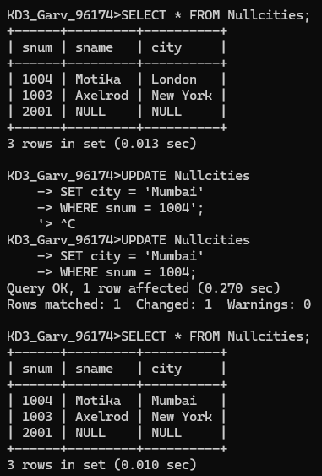

6.
